Computer tasks for maintaining and replenishing inventories in Santa Ana and San Miguel

Post mission

Delete older glasses as necessary – REIMS now provides a utility to do that. Utilities Inventory / age analysis

Create files for entry of re-used numbers to fill available slots -- Utilities / Make files for entering re-used numbers.
That operation makes files with different series of re-used numbers and create zip files backups for each entry person from which to restore

Here are the instructions from the manual:

How to make files for entering re-used numbers
Under Utilities choose Make files for entering re-used numbers

It brings up the following screen to divide up the re-used number for entry on multiple computers. It creates files to be used to restore on each with unique numbers. After each non-master computer operator has completed entry, he/she must use Export/Import - Export re-used numbers. The exported files must be imported by the Master by using Export/Import - Import re-used numbers. The file name is READD.DBF. Currently the folks doing the entering simply send backups for their work. See below.

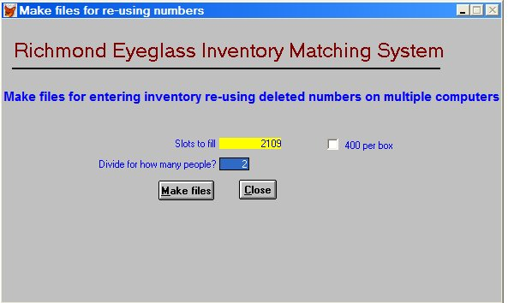

Friends of ASAPROSAR has found that large egg cartons will hold 400 glasses so we ask each entry person to fill a box. If 400 per box is checked, the program will assign the number of people to fill egg cartons.

Import the re-used entry work
Each entry person sends a backup of their work. The files will be named
[R + month + date + year].ZIP i.e. a file backed up on 07/14/09 will be named
R071409.ZIP. Since there are usually several people entering, their backups must be kept separate. I have a sub- folder for each person in which I store their backup.
Each backup zip file has a file named READD.DBF. That has the data that needs to be imported. I use My Computer to open the zip file and then extract READD.DBF renaming it something like RASAB309.DBF for
Re-Add + Santa Ana + Box 3 + 2009.

Keeping these files in easily findable folders and labeling them carefully makes the rest of the importing process straightforward.

Here are the instructions for importing from the manual:

How to import reused numbers to the Master

1. Type ALT e for Export/Import and choose Import re-used numbers.

2. A confirmation box will ask Ok to import now? with the Cancel button in focus. To cancel hit ENTER. To continue importing, type o (lower-case letter O) for "OK. An "Open" box will appear. Select the file to be imported.. The program will import the file and proceed to update the master file. A message confirming the number of records updated will appear. The program will then delete all records on READD.DBF and create a file of available numbers*.

3. The backup procedure will be started automatically at this point. Follow the instructions above under How to backup.

The backup in 3. above was used when we were re-filling open slots on site in Santa Ana on a separate computer and needed to complete the cycle so more could be entered. I generally ignore that now until the final import – at that point we have an interim Master file.

If the folks in Santa Ana will be dispensing after we leave (as they seem to be doing now), we may want to fill those slots as well. That entails determining what slots have opened, deleting those records from the Master we have been working on and then creating a file or files to enter more reused numbers.

I have worked out a method for this (and have done it this year) and will add a feature to REIMS to allow you to do it next year.

